James Lee

CS-255-J7045 System Analysis and Design 23EW5

June 17, 2023

**Project Two: System Design Document**

## UML Diagrams

### UML Use Case Diagram

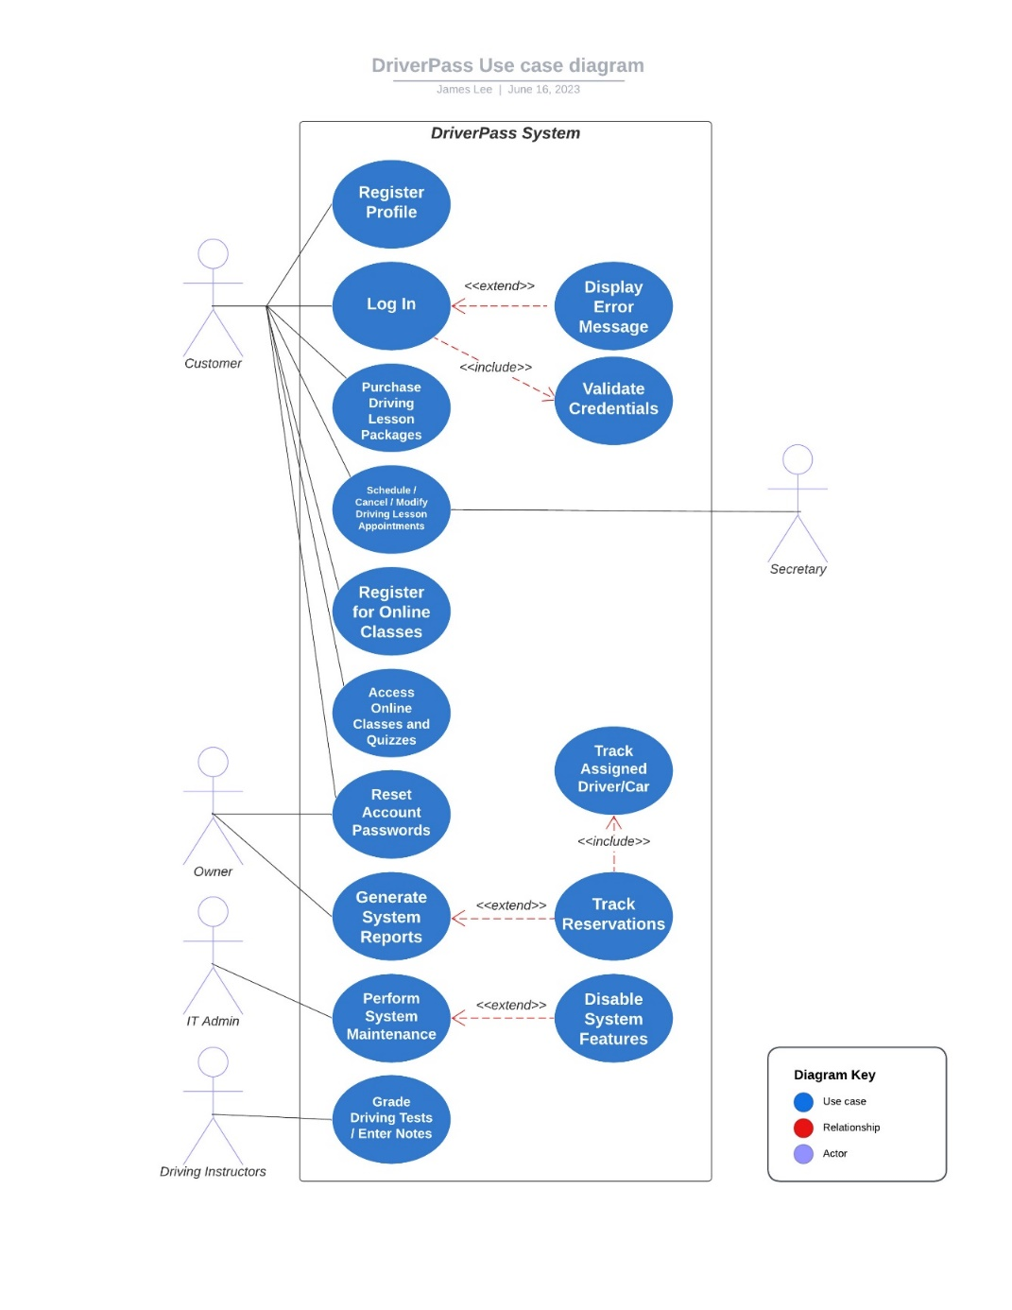

### UML Activity Diagrams

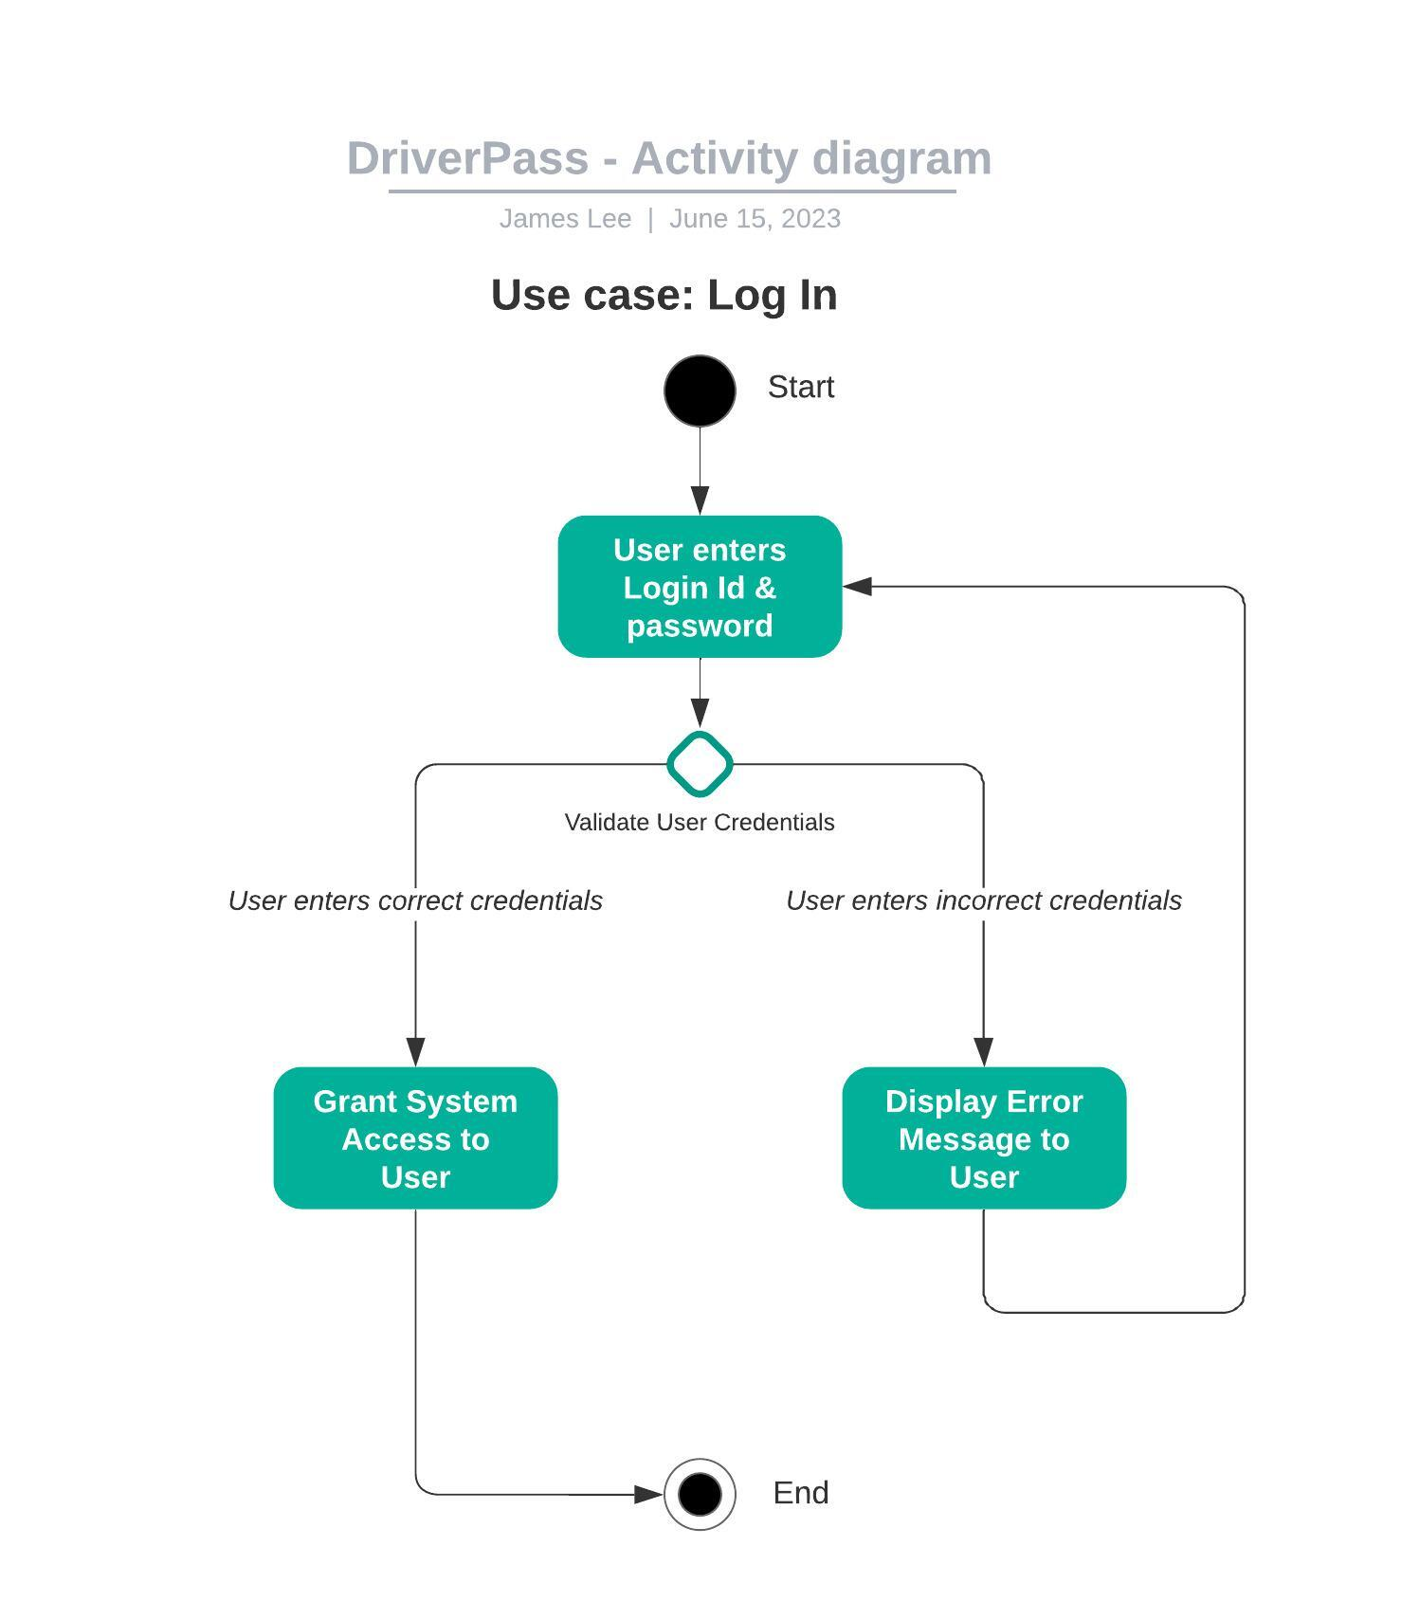

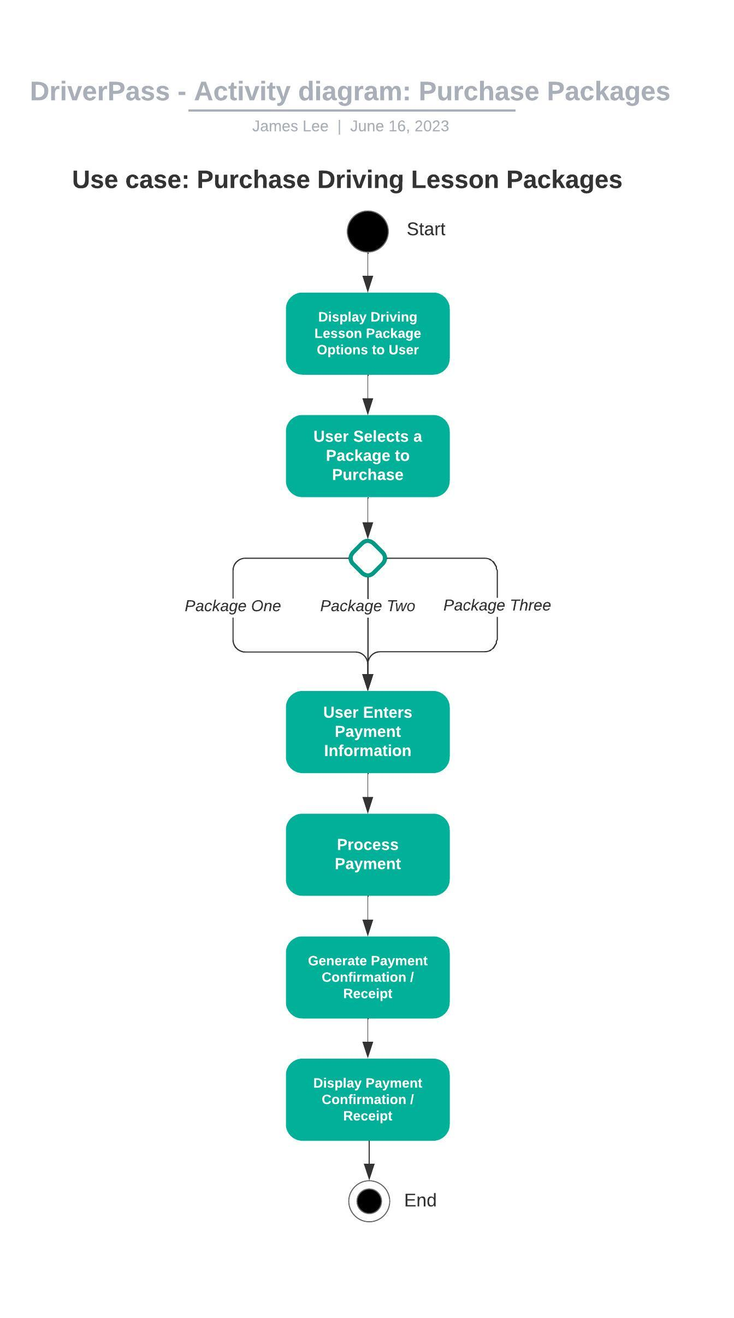

### UML Sequence Diagram

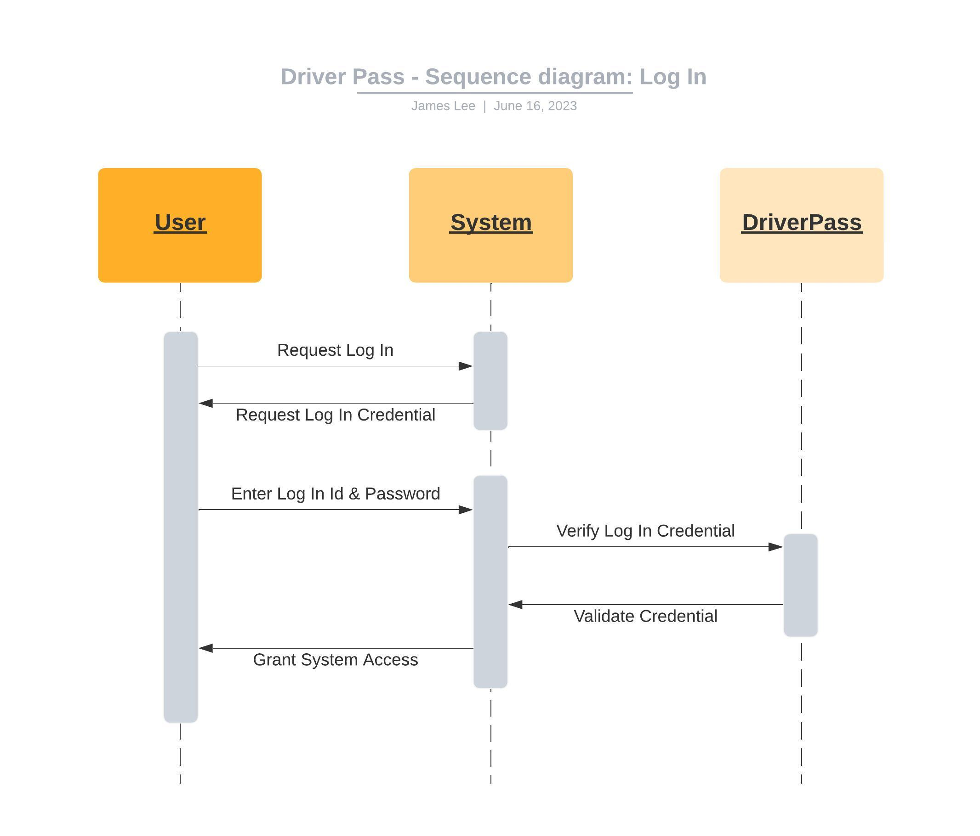

### UML Class Diagram

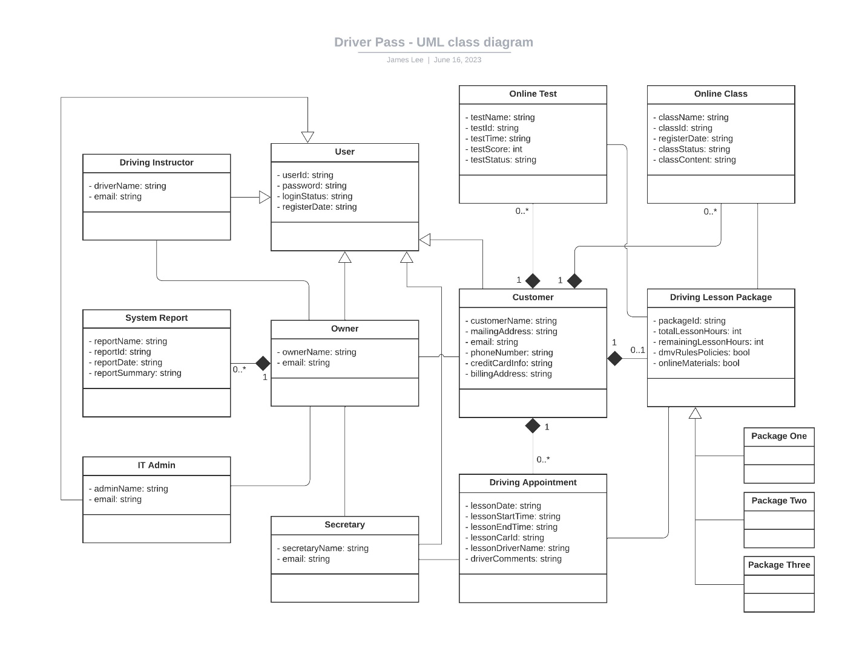

## Technical Requirements

**Hardware**

* Mobile device (iOS, Android, iPadOS, Windows), or
* Desktop / Laptop Computer (Windows, Mac, Linux, etc.)
  + Users shall have a device (mobile or otherwise) meeting minimum hardware requirements

**Software**

* Data encryption software
  + Transfer of sensitive data (login credentials, payment info, etc.) between the client and server must be encrypted

**Infrastructure**

* Cloud provisioning
  + For databases, integrated backup, and security features
* Internet access